PEWC BARRELS SUPER SLOT RACE!!
OVER $14,000$ TO BE PAID OUT
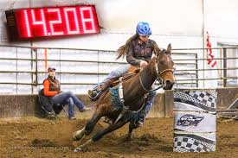
2D Payouts
1st- $1,700
2nd- $1,400
3rd- $1,100
4th- $900
5th- $600
1D Payouts
1st- $2,500
2nd- $2,100
3rd- $1,700
4th- $1,300
5th- $900
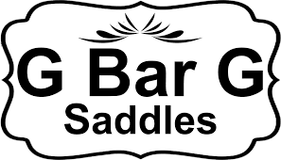
SADDLE TO THE 1D WINNER!!!
- $500 Entry Fee
- Previous owners get first option to renew
- First Payment due on March 1 st, 2018
- Second payment due by June 1 st, 2018
- MUST be paid in FULL by June 1st, or $50 late fee applies
- Waitlist and lease options available

- To be Held at PEWC Finals at R&J Arena, Verndale MN
- October 20th, 2018
- Contact: Amber Webber
- Email: Amber.Webber@outlook.com
- Cell: 651-216-4653

